Bio-data
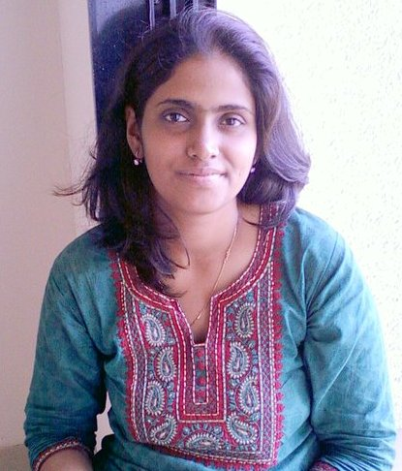
Name : Kalpana Sumant Chikhalkar
Father’s Name : Sumant Bhahu Chikhalkar
Date of Birth : 16th April 1986
Address : 2/40, Mayur Society,
Kirti Collage Lane, Dadar,
Mumbai – 400 028.
Contact Person : Mrs. Suvarna S. Chikhalkar
Contact no. : 9321425146
Email : kapssc86@gmail.com
Height : 5’ 7” (169 cm)
Blood group : A +ve
Body type : Average
Physical disabilities : No
Complexion : Fair
Spectacles : Yes while reading
Mangal : No
Education : Perusing last year MBA in Marketing from
Mumbai University, B.Com from Mumbai
University

Occupation : Working as Senior Sales Officer in ICICI Bank,
Mahalaxmi Branch
Family background : My Father is retired, Mother is housewife and
one younger brother working in Henkel

Expectation : Matching to my profile. He should values
tradition and customs.

Village : Chaner, Alibag

Bio-data

Name : Kalpana Sumant Chikhalkar
Father’s Name : Sumant Bhahu Chikhalkar
Date of Birth : 16th April 1986
Address : 2/40, Mayur Society, Kirti Collage Lane,
Dadar, Mumbai – 400 028.
Contact Person : Mrs. Suvarna S. Chikhalkar
Contact no. : 9321425146
Email : kapssc86@gmail.com
Height : 5’ 7” (169 cm)
Blood group : A +ve
Body type : Average
Physical disabilities : No
Complexion : Fair
Spectacles : Yes while reading
Mangal : No
Education : Perusing last year MBA in Marketing from
Mumbai University, B.Com from Mumbai
University

Occupation : Working as Senior Sales Officer in ICICI Bank,
Mahalaxmi Branch
Family background : My Father is retired, Mother is housewife and
one younger brother working in Henkel

Expectation : Matching to my profile. He should values
tradition and customs.

Village : Chaner, Alibag

